**Gametophyte culturing experiment (Summer 2023)**

**Goals of study**

* See how gametophyte reproduction, development, and growth is affected by various pCO2 and temperature levels
  + Measure the following in gametophytes over the experimental period: sex ratio, length, surface area, number of oogonia per female (proxy for percentage of fertile females)
* See how gametophyte photophysiology (respiration and photosynthesis) is affected by various pCO2 and temperature levels
  + Measure respiration and photosynthesis over the experimental period
* Compare 2 different sites
* Temperature levels:
  + 12 (avg bottom temp in Sept at Seattle Aquarium 10m sonde),
  + 18 (to match Brooke’s work and others – physiological limit)
* pH levels:
  + Ambient (8.0),
  + (7.5) (avg bottom pH, 7.8 according to Seattle aquarium 10m sonde, -0.3 per ICPP 8.5 scenario. Also corresponds with avg winter pH at WI)
* ^this corresponds to 4 treatment levels (4 tanks).
* For examples of desired figures, see: <https://doi.org/10.1016/j.marpolbul.2018.07.072>

**Pre-experiment questions/goals – est. time = 2 months**

* Figure out how to use respirometry attachment on MINI-PAM
  + What PAM settings should we use?
  + How many gametophytes per chamber?
    - 100ug/mL chlorophyll
      * Gametos of L. saccharina have 0.3-0.7pmol Chl a per plant (Gerard 1990)
    - ~~Run through pre-weighed filter to get gameto weight? Weigh filter on fancy scale, dry in oven, weigh again.~~ 
      * ~~See if you need to pre-dry filters~~
* ~~Confirm that pH does not change substantially in cell wells through time, with and without kelp inside.~~
* ~~Do I need to aerate bottles of F/2?~~
* ~~Develop a protocol for imaging gametophytes~~
  + ~~Put together an ID guide of the different sexes and stages, for undergrad helpers~~
  + ~~Figure out a reasonable sample size (how many fields of view to take pictures of per sample – can be based on standards in the literature)~~
  + ~~Use cultured gametophytes to test.~~
* ~~Directly before the experiment~~
  + ~~Calibrate the pH, temperature, and oxygen probes~~
  + ~~Order more gas cylinders~~.

**~~Making f/2 solution solution (Guillard & Ryther 1962, Guillard 1975)~~**

* ~~Make sure you have necessary items. Acid-wash as necessary.~~
* Add in geranium dioxide?
  + 10 ppm? (Luning and Neuschul 1978) for first 4 days
  + 2 mL per 1L PESI (Gao et al. 2019a)
  + 1 mL GeO2 / L PES, just for the first week (Izquierdo et al. 2002)
  + GeO2 can inhibit not only diatom blooms but also kelp gametophyte growth (Shea & Chopin 2007)
  + 100 μL of GeO2 (0.04 g l−1) was applied to avoid overgrowing of diatoms – Fernandez et al. 2021, cited Shea, R. & Chopin, T. Effects of germanium dioxide, an inhibitor of diatom growth, on the microscopic laboratory cultivation stage of the kelp Laminaria saccharina. J. Appl. Phycol. 19, 27–32 (2007).
  + 20 ug mL-1 (Gao et al. 2013, 2016)
  + 3 ug L-1 (Gao et al. 2013a and b)
  + Shouldn’t need to worry about diatoms if you omit silicate from the f/2 media (Mabin et al. 2019). Silicates were omitted from the recipe to reduce the likelihood of diatom contamination, which eliminated the need to use germanium dioxide (GeO2). GeO2 is used as a diatom suppressant in Laminaria culturing due to its effect of arresting diatom cell division (Lewin 1966, Shea & Chopin 2007); however, GeO2 may have inhibitory effects on kelp gametophytes (Shea & Chopin 2007).
  + 0.1 mg/L (Murura et al. 2021; also cite Shea and Chopin 2007
  + **Final decision: 0.05mL/L based on Shea & Chopin 2007; it’s just above their minimum conc.; they say benefits at 0.02mL/L. 0.10 or above will have positive effects on their growth and we want to avoid this confounding factor.**

**Equipment needed**

* MINI-PAM-II with oxygen attachment
* Inverted microscope
* Camera
* Monitor for inverted scope
* Memory card for camera
* Tanks (4 experimental tanks, 2 sea tables)
* Seawater
* Autoclave
* F/2 solution (will need to mix regularly)
* Truck
* Kayaks
* 5-gallon bucket
* Betadine
* Geranium dioxide
* Cooler with ice packs
* Pan or plate (something to put in the fridge)
* Paper towels
* 70% EtOH
* 12-well plate
* Gloves
* Hemocytometer
* ImageJ
* Light meter
* Parafilm

**Field work (day before experiments) – Workflow**

* Day before:
  + ~~Calibrate Sonde~~; if visiting WI also calibrate HOBO logger.
  + Place the large graduated cylinder with autoclaved seawater in the fridge.
* To the field, bring: Kayaks, life jackets~~, laptop with Exo3 software, Sonde, rope~~, 3 glass bottles to collect alk, 3 brown amber bottles to collect pH samples, small cooler, ice packs for small cooler, another small cooler filled with loose ice.
* Arrive at field site, ~~start Sonde recording data~~, deploy kayaks.
  + ~~Tie Sonde to the side the kayak and allow to hang over the side of the kayak while paddling.~~
  + Bring the alk bottles, pH bottles, and the small cooler with ice packs.
* Collect approx. 15 fronds with ripe sorus patches (ripe = dark patch, white outline around the edge). Place these in a small cooler with some seawater.
* Collect 3 alk and pH samples.
* Paddle back to shore. Put alk and pH samples in the cooler with ice. Drive back to lab.
* Back at lab, clean up your lab bench. Wash your hands with soap and then keep them out of seawater. Wipe down the surface of your desk with a paper towel dampened with 70% alcohol to sterilize it. Put down several clean paper towels to work on.
* Set up the following: a stack of clean paper towels, a bath with sterile seawater with **5mL/L** betadine, a squirt bottle with sterilized seawater, a bath with sterile seawater alone, and a tray or pan lined with paper towels.
* Put on gloves. One by one,
  + remove them from water,
  + use a paper towel to roughly scrape along the surface of the sorus patch (to remove any epiphytes),
  + dip the patch in the betadine solution for ~30 seconds (also helps kill bacteria, etc.),
  + spray down with the squirt bottle of sterilized seawater,
  + then dip in the sterile seawater bath to rinse for 5-10 mins,
  + then place in the paper towel-lined tray.
* Repeat with all sorus patches. Cover the tray with damp paper towels (so that the patches are moist but not wet) and **place the tray in the fridge** overnight.
* **Place F/2 in 12C sea table** to get to temperature overnight.
* Run the three alkalinity samples through the titrator.
* Measure the 3 pH samples with the Orion probe and on the Spec.
* Put food bin full of PES in 12C water bath for spawn-out.

The next day

* Turn on spec and water bath. Note time; set timer for 2 hours from now.
* Turn on spec and begin calibration/CRM/etc. process.
* **Take a spec sample and an alk sample from each header tank.**
* Clean up your lab bench. Wash your hands with soap and then keep them out of seawater. Wipe down the surface of your desk with a paper towel dampened with 70% alcohol to sterilize it. Put down several clean paper towels to work on. Prep a large beaker with 20um mesh rubber-banded around the top.
* Take out F/2 from the water bath. Put it in a cooler with ice packs. Put an air stone in it, and a temperature probe.
* Create the spore suspension. Retrieve the tray of sorus patches from the fridge. Put on gloves. Place the sorus patches in the bath. After a few minutes, the spores should start to release. The water should turn cloudy.
* Wait approximately 1 hour, then remove spent sori and air stone. **Wait an additional 30-60 minutes for mucilage to settle.**
* During this time, prep Parafilm by cutting long strands and short rectangles.
* Filter spore suspension (“slurry”) through 20 um mesh.
* Pipette out 10 microliters of the spore suspension into the hemocytometer. Add a thin glass slip on top of the Hemacytometer counting chamber prior to placing under the microscope. Wait 60 seconds for the spores to settle.
* Count the spore concentration under the inverted scope. Calculate out a dilution factor.
  + Desired dilution factor: 8,000 spores/mL
  + 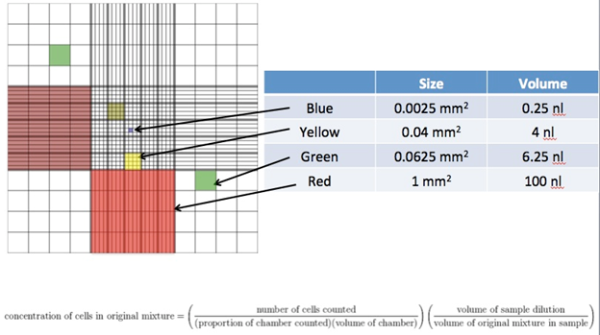
* Clean the hemacytometer with a kimwipe dipped in 70% ethanol solution.
* Prep the culture plates. Wearing gloves, bring each culture plate to the station and place it on the sterile pad surface. Remove the top cover and place it top down on the sterile pad.
* Based on the calculated dilution factor, pipette the spore suspension into the culture plates.
* Pipette the f/2 culture media in each of the wells. Do not touch the inside of the culture plate, only on the sides. Don’t put the pipette down on the surface. Put the pipette back into the sterile jar to keep it clean.
* Stretch Parafilm over the top of the well plate. Then put the lid on the well plate. Wrap again in Parafilm.
* Place culture plates into experimental chambers.
  + N= 56 wells per treatment
    - 7 wells per treatment
    - Keep all wells in the same well plates the same; can mix and match between rafts.
  + <https://www.michaels.com/product/24-eva-foam-half-round-dowel-by-artminds-10624918?com_id=pdp_AlsoLike&path=youMayAlsoLike>
* **Keep lights off for the first 24 hours (at least overnight).**
* Recommended light settings:
  + **40-60 PAR (μmol m-2 s-1) (Weigel et al. in press) and 15:9 hr light:dark cycle**
  + **Darkness for first 24 hours.**
* Spores should settle over the next ~18 hours. Or next 3 hours?
  + After spores settle, take photos, and then pipette out dead spores.
* Should have control cultures with just water (no gametos) as well (Leal et al. 2017a)
* Every few days, take photographs of a subset of gametophytes from each treatment (see below).
* Change water every 3 days.
  + Measure pH of culture media before and after each water change.
  + Gaitan-Espita et al. changed water every 3 days.
* Germ tubes should start to appear after 24 hours. 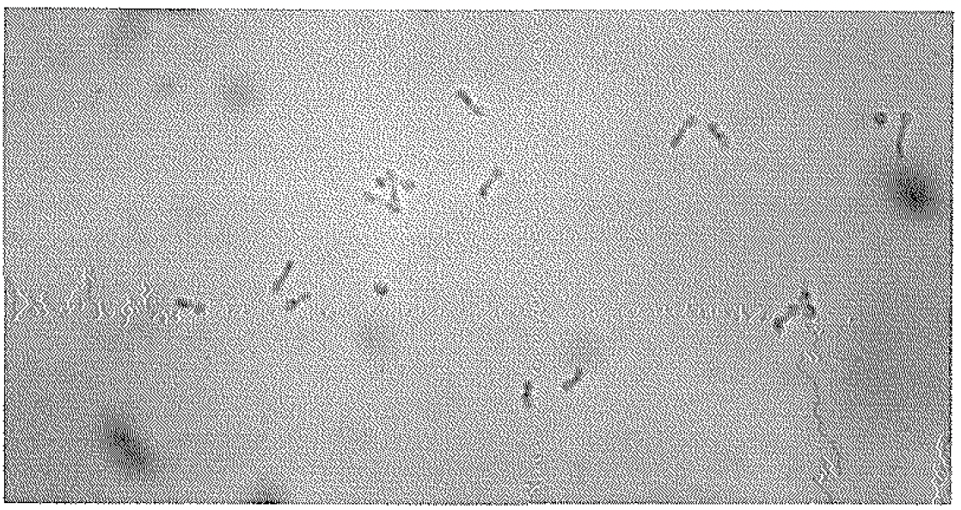1d
* These tubes soon branch to form typical filamentous vegetative gametophytes. Female filaments are 2-3x larger in diameter. 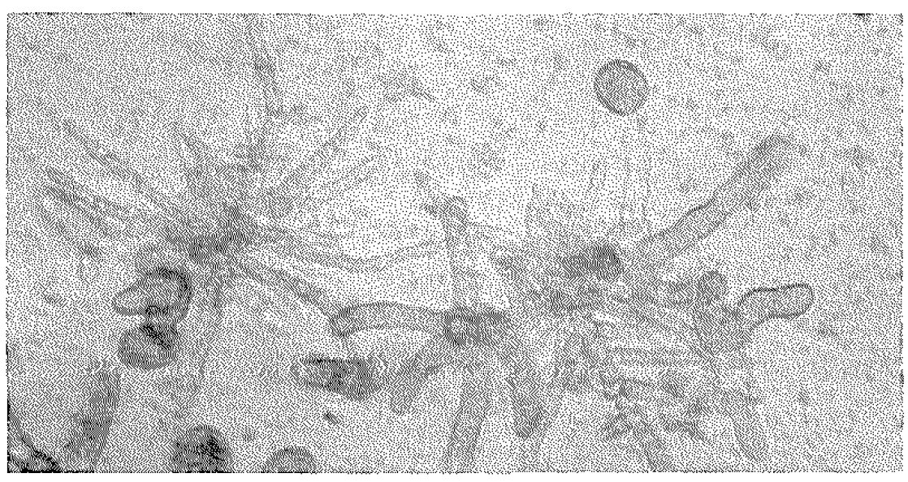14d
* Within 20-14 days, reproductive structures begin to develop.
* From 18-21 days, young sporophytes become evident. 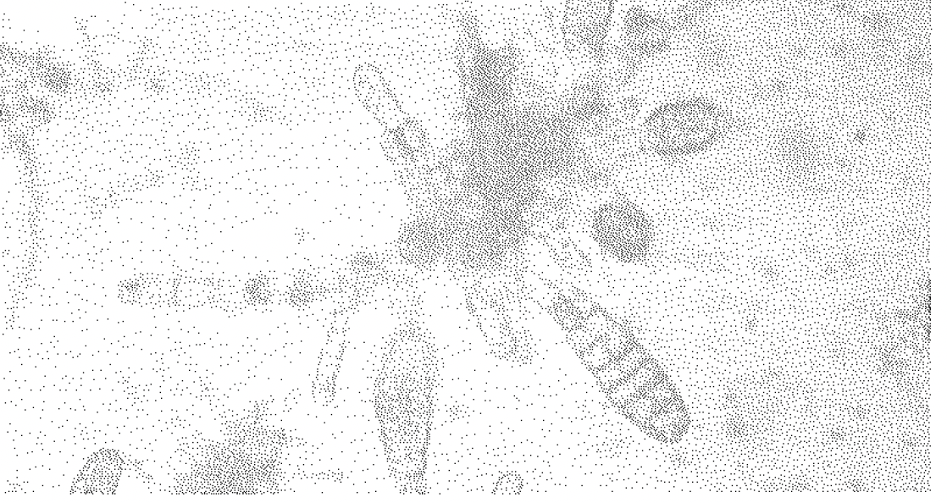21d
* After ~30d, young germlings are 1-2mm in length and can just begin to be seen by the eye as a brown fuzz.
* On the 3rd week, perform photosynthesis/respirometry trials (see below).
* After approximately 2-3 weeks the gametophytes will become fertile (producing eggs and sperm) and the eggs will become fertilized to form a zygote. The zygote will develop into a juvenile sporophyte.
* Anticipated experimental duration: 5 weeks (depends on when juvenile sporophyte stage is reached)
* Photograph info:
  + Frequency of photograph-taking:
    - Spore settlement success photos taken after ~5 days.
      * Germinated/ungerminated spores.
    - Gametophyte photos were taken on day 10,
    - and weekly after that for 3 weeks (days 17, 24, 31).
    - Juvenile sporophyte photos were taken on days 32 to 34.
  + Protocol for photograph-taking:
    - Wash your hands. Wear gloves whenever handling petri dishes.
    - Wipe down the microscope area/anywhere the petri dishes are going to touch with 70% EtOH.
    - Wipe condensation off of the bottom of each well plate.
    - Magnification: 20x
    - Make sure scale bar is present at the bottom of the screen and is set to the correct magnification (e.g., 20x). Do this by right clicking, then clicking “scale bar”. This will make the scale bar show up. Then click right click again and hit “Set Scale” and select the magnification you are on. Do this every time you switch magnification!!
    - Between each well, take a blurry photo, to indicate you are moving on to a new well.
    - Between each well plate, take a dark photo
    - Take 5 photos per well. Take in a star-shaped pattern (top, left, bottom, right, center)
    - Try to be as fast as possible with photographing so as to not let the gametophytes get too warm. Aim for < 3 minutes per plate. Transport plates back and forth using a Styrofoam cooler box with an ice pack.
  + Metrics measured from photos:
    - # viable gametophytes
      * 300 per replicate
    - # male gametophytes
      * Males are smaller with thinner cells, with many branches and irregular growth patterns.
    - # female gametophytes
      * Females are clearly bigger with plumper cells. Females have a simpler morphological structure and growth pattern.
      * Week 1 :# females with germ tube (indicates meiospores have settled and are developing into gametophytes)
        + 200 meiospores
        + 100 female gametophytes
        + 200 female gametophytes for each of 4 experimental replicates
        + 2 slides per treatment with 25 gametos
        + 250 females from each treatment (5 groups of 50)
      * # female gametophytes bearing juvenile sporophytes (out of total number)
        + 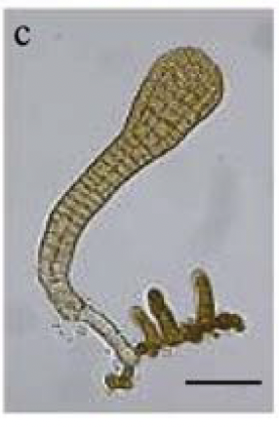 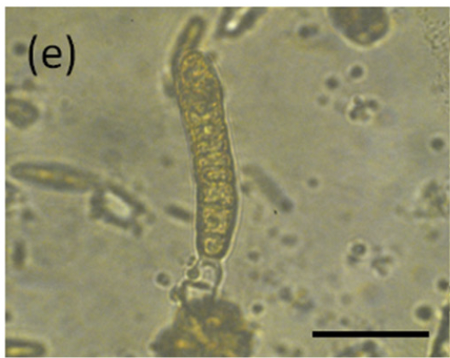
      * # female gametophytes with oogonia (eggs) (out of total number)
        + 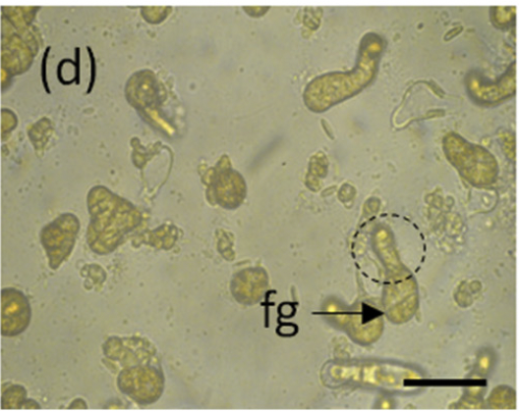Gonzalez et al. 2018 L. trabeculata – female gametophyte with oogonium (dashed circle)
        + # eggs per female
      * # females with released oogonia
      * # female gametophytes without oogonia (out of total number)
      * Female fertility metrics measured ~day 30 / day 35
    - Length and width of a subset of gametophytes
      * Sample size:
        + 5 random individuals per replicate dish
        + 20 females per slide (20x4 = 80 per treatment)
        + 100 male and 100 females
        + Randomly select 5 per petri dish
        + 100 per treatment
        + 30 per petri dish
        + 20 males and 20 females from each treatment
      * How often measured:
        + Daily between day 14 and 20
  + Metrics calculated:
    - Germination rate (# germinated / # initially settled spores) x 100
      * After 24 or 48 hours or on day 3 or on day 5, measure germ tube production for 100-500 meiospores in each experimental condition
      * 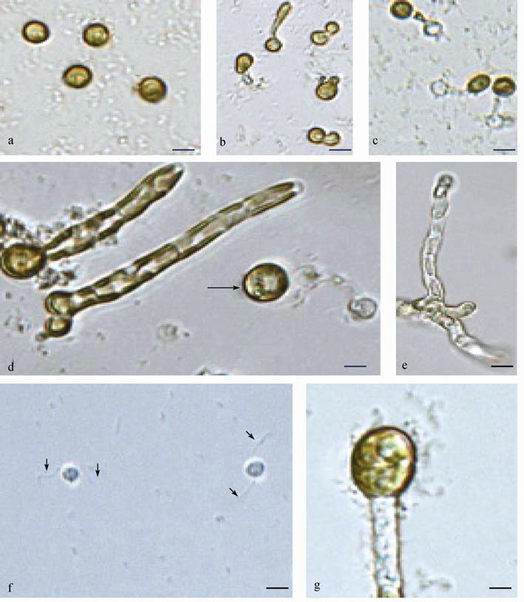Spore. Fu et al 2010; *C. costata*
      *  Germ tube of *C. costata*
      * 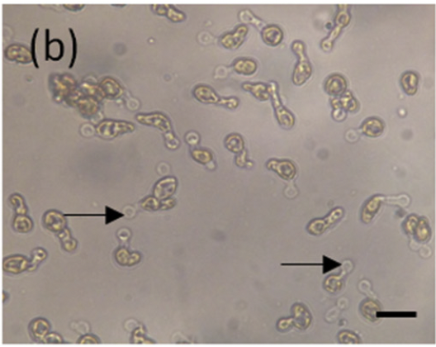Arrow shows germ tubes in Lessonia trabeculate. These spores are germinated. (Gonzalez et al. 2018)
      * Day 8 young gametophytes of S. japonica 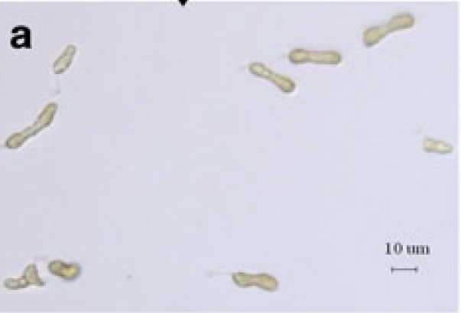
      * Also count ungerminated and dead spores. Ungerminated spores are a proxy for resting or dormant spores.
        + Define dormant spores are those cells that exhibit pigmentation and undisrupted shape at the end of the experiment, but lack development of germination tubes, which are produced by active cellular metabolism (Gaitan-Espita et al. 2014)
    - Survivorship: # viable gametophytes (plastids with brown pigmentation present inside gametophyte and no evidence of plasmolysis) / initial density; Visch et al. 2019
      * 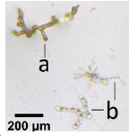Alsuwaiyan et al. 2021. (a) shows viable gametophyte; (b) shows non-viable gametophytes. At least 1 cell should be properly pigmented.
      * Plasmolysis: when chloroplasts contract to the middle of the cell 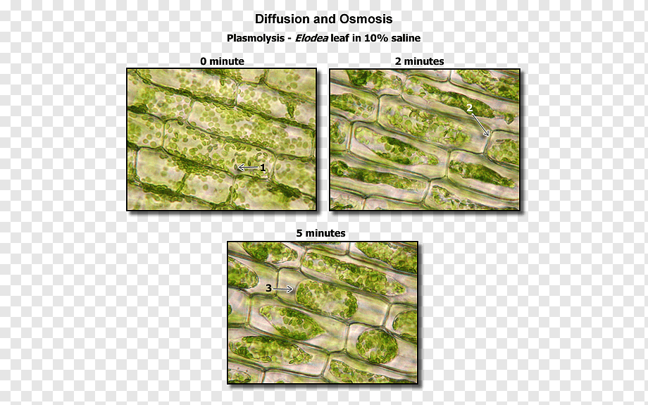
      * Can also do based on density (e.g. Schwoerbel et al. 2023)
    - Reproductive success (sporophyte density):
      * Reproductive success was estimated following Lee & Brinkhuis (1986):  
        Reproductive success (%) = [a / (a + b + c)] x 100  
        where a is the number of female gametophytes bearing juvenile sporophytes, b is the number of female gametophytes with oogonia and c is the number of female gametophytes without oogonia.
      * Fecundity is calculated following Lee & Brinkhuis (1986) as:
        + F = (a + b) / (a + b + c)  
          where a is the number of female gametophytes with sporophytes, b is the number of female gametophytes with oogonia and c is the number of female gametophytes without oogonia.
    - Size (relative growth rates):
      * Maximum branch length
      * RGR (% d−1) = [(lnL2 − lnL1) / t2 − t1] x 100   
        where L1 and L2 are the lengths (RGRL) or widths (RGRW) at times t1 and t2 in days.
      * “After the gametophytes attached to the glass slides, they mainly grew horizontally, although vertical growth was also observed to lesser extent. Therefore, we estimated the enlargement of the photographic area of gametophytes in a horizontal direction as the growth of gametophytes. If the male gametophyte formed antheridia, we measured the area including the antheridia. In contrast, if the female gametophyte became fertile and parthenogenetic eggs were released from oogonia, the area of the eggs was excluded.” (Komazawa et al. 2015)
      * In order to discriminate between acclimation of growth rate over time and overall growth rate, RGR was calculated between consecutive time points and over the entire experimental period separately (Franke et al. 2021)
      * Can also measure based on diameter: “Growth was measured using a Microm image analyser. The increase in diameter of the primary cell of the female gametophyte is a reliable character for the estimation of vegetative growth (Lüning and Neushul 1978; Lüning 1980).” (Izquierdo et al. 2002)
    - Sex ratio
      * 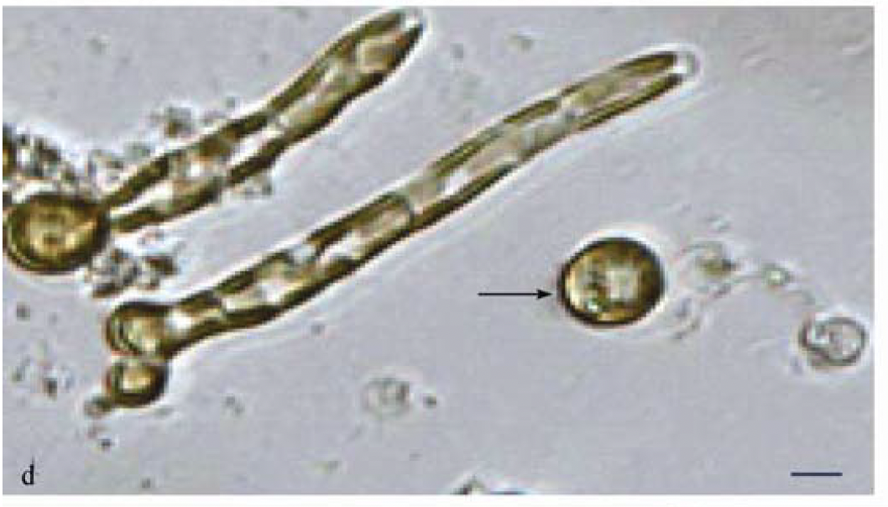Fu et al. 2010. Female gametophytes with eggs (round things) in *C. costata*.
      * Male gametophytes of C. costata. 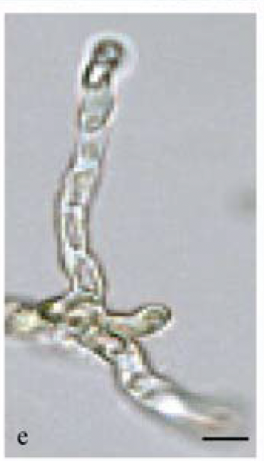
      * 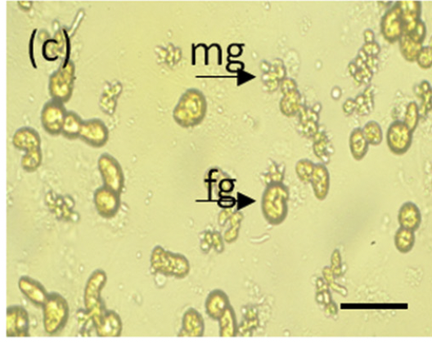L. trabeculata (Gonzalez et al. 2018). Mg is male gametophyte, fg is female gametophyte.
      * Measure on day 14-ish

Male (a) and female (b) gaemtophytes under vegetative growth

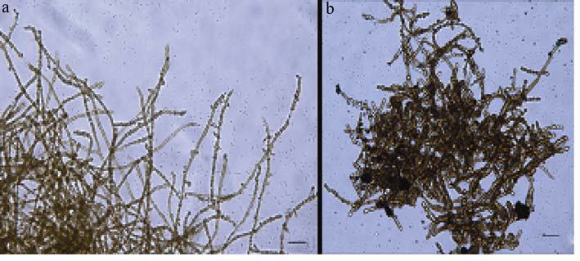

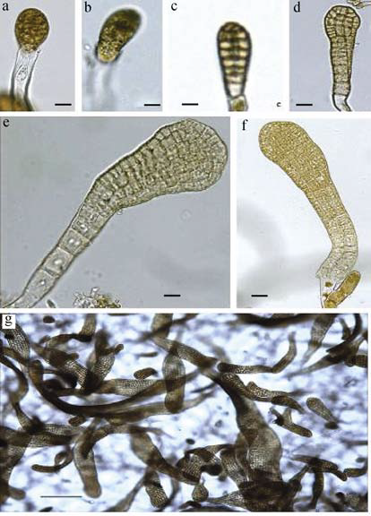(Fu et al. 2010). Growth of sporophyte from egg onwards.

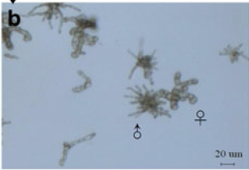S. japonica male and female gametophytes day 16

**Respirometry:**

* + Sample size:
  + Weighing protocol:
    - Pre-dry filters overnight before getting weights.
    - Dry filters at 60C overnight.
  + How many blanks do I need to run?
    - Run 1 blank for each sample. For each sample, randomly select one of the six wells in the well plate (have a random number generator pick between 1 and 6). Pipette out 15.5mL from the well. Discard the liquid into a small STERILE beaker. Now using the pipette, gently scrape along the bottom of the well plate. Agitate the water by gently pipetting in and out. Suck up the remaining 500uL of liquid. Use the wide-mouthed pipette tips to ensure biological material is sucked up. Place this aliquot into the cuvette. Place the beaker containing the remaining 15.5mL of water back in the water bath so it stays at temperature. This will be your “blank” water. Measure this blank directly after measuring the gametophytes. Adjust readings so that each light level is only ~2 minutes. If rate doesn’t change during the different light levels (it shouldn’t), switch to just doing 5 mins in the dark.
  + Note: from Fain & Murray 1982: “Preliminary experiments revealed that detaching gametophytes from their microslide substrata did not affect photosynthetic or respiratory performance (Sundene 1958, Vadas 1972, Chapman 1973).”
  + The day before:
  + Place several filters in the oven to dry overnight at 60C.
  + Assemble respirometry equipment.
    - Set up water bath. Use the sea tables as your water source. Assemble setup on push carts in the big room. Place small pump in water bath with tubing running in and out. Hook up to cuvette (see below).
    - Assemble the apparatus as pictured.
    - 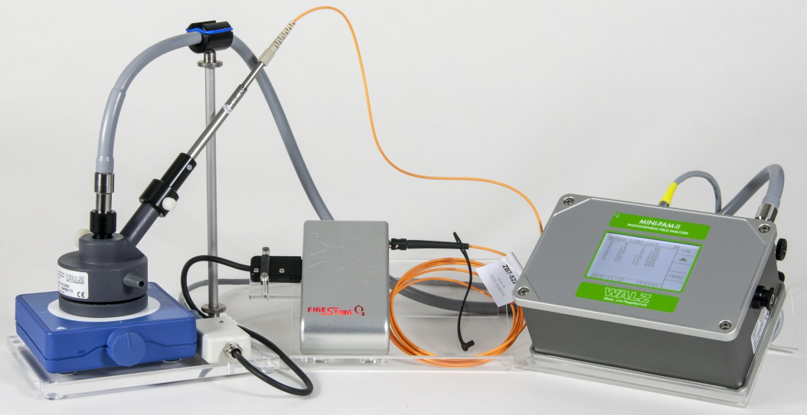
    - 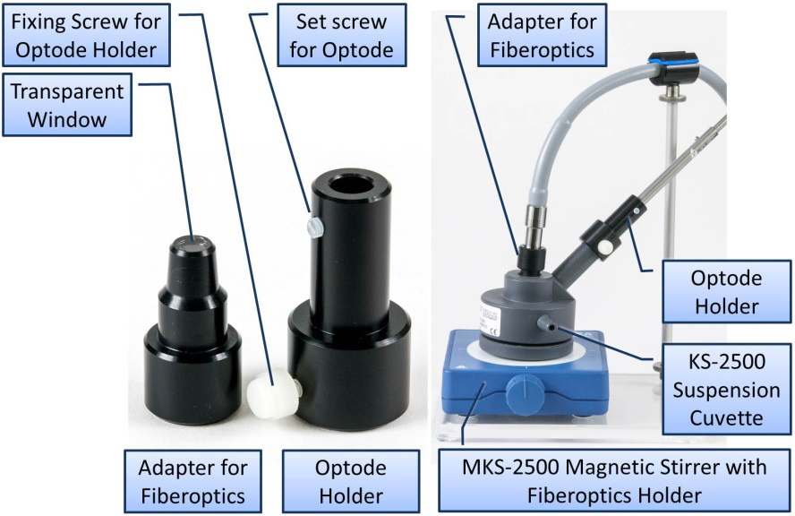
      * Place clear plastic tray with long metal pole on working surface near water bath. Clear plastic tray is free-floating in respirometry/PAM box.
      * Place stir plate on top and line up the legs with the divots. Plug the stir plate into power using the power cord in the box. Stir plate and power cord are in their own box; small white cardboard box.
      * Place cuvette (see photo above) on top of stir plate. Cuvette is in its own plastic bag loose in respirometry/PAM box.
      * Open respirometry box (grey plastic Pelican case with red hinges that says ‘Firesting’. Pull out Firesting respirometry unit. Pull out adapter for fiberoptics and optode holder as well and add to suspension cuvette as in photo above. Do not add the adapter yet, but keep it handy.
      * Add in an o-ring and a stir bar to the cuvette. Use the small plastic hook tool provided to ensure that the O-ring is lying flush against the cuvette lip. Both of these things are also in the grey respirometry case.
        + The O-ring is open to permit pressure equilibration between cuvette inside and atmospheric pressure. Also, the O-ring gap serves as escape for bubbles when the fiberoptics adapter touches the surface of the suspension.
      * Open the metal briefcase containing the Mini-PAM. Pull out the Mini-PAM itself. If desired, place MINI-PAM on the slanted plastic piece provided for easier reading of screen.
      * 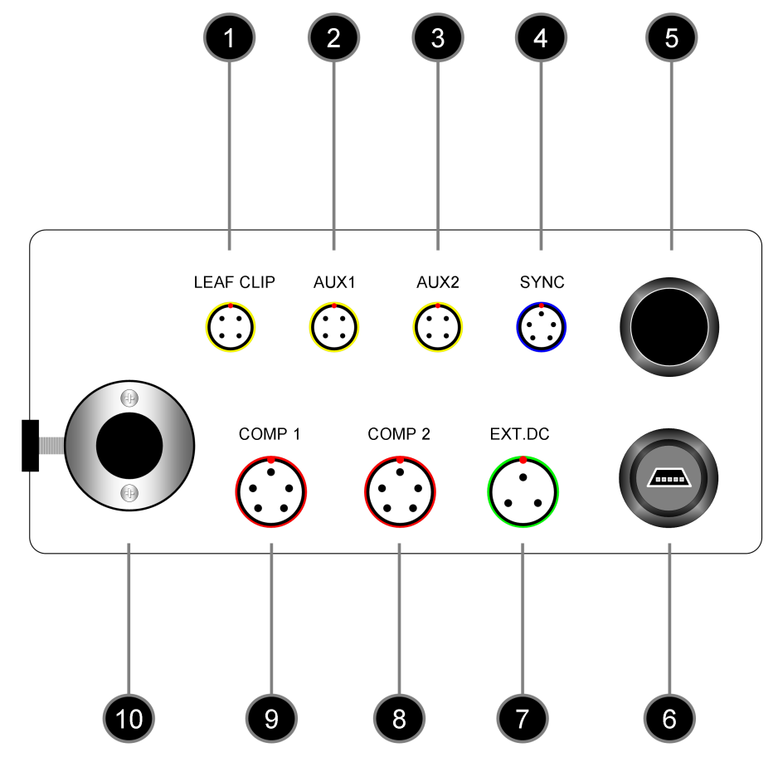
      * 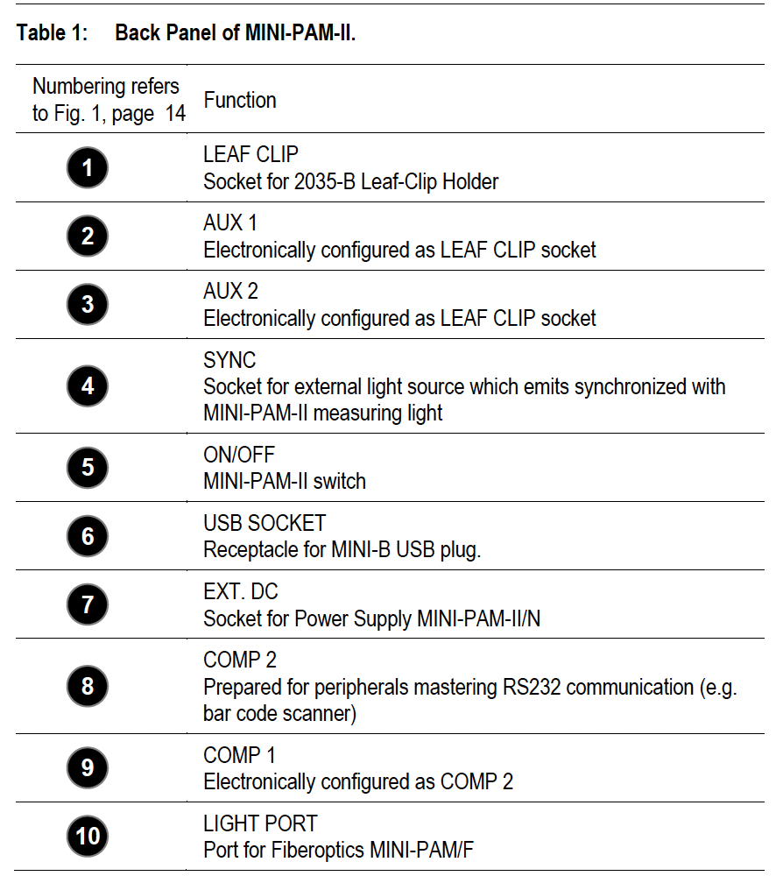
      * Pull out power cord (two pieces) and plug the MINI-PAM into power (green plug). On the PAM end, make sure to line up the red dots on the plug and the PAM to properly inset it.
      * 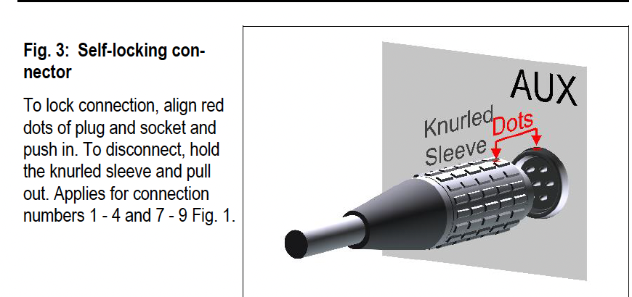
      * Pull out USB connector (round end with blue plastic cap) and plug into MINI-PAM and the computer you are going to use.
      * Plug grey cord labeled Leaf Clip into the PAM in the Leaf Clip hole and the other end into the adapter coming out of the Firesting unit. On the PAM end, make sure to line up the red dots on the plug and the PAM to properly inset it. On the Firesting end, make sure to line the tines up properly and do not twist the cord to tighten or you may damage the metal tines. Twist metal fastener to tighten.
      * Add the oxygen probe.
        + 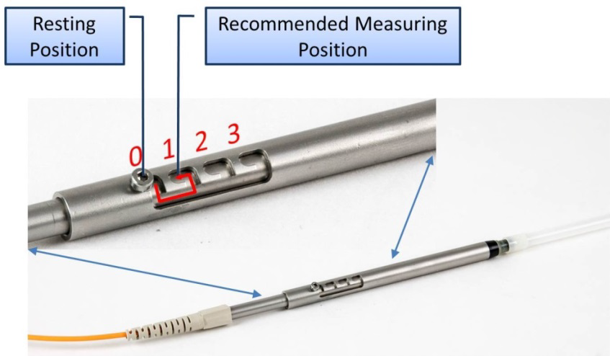
        + Oxygen probe is in its own plastic bag in the big respirometry/PAM box.
        + Do no bend orange fiber optic cable!! Follow the natural curves of the cable.
        + Plug the sensor into the Firesting respirometer unit (port with red rubber cap). Metal slots on plugs should line up. Push in and then use rubber twist on oxygen probe side to fully attach. Do not twist cable itself!!
        + When handling the sensor, always keep fiber in retracted position unless the sensor is secured in the cuvette.
        + Firmly hold plastic cone of needle and remove protective needle cap.
        + Unscrew the plastic screw holding the plastic tube in place and remove plastic tube.
        + Ensure that the sensor tip is not hitting sidewall or bottom of the beaker or flask, or any other solid object. Always use a proper lab stand for mounting the oxygen sensor!
        + On the cuvette, slip the optode adapter over the optode port on the cuvette. Tighten up gently the plastic fixing screw for optode adapter.
        + Leave pushbutton in resting position. Remove protective cap.
        + Immerse needle tip in distilled water and move sensor several times from position 0 to position 2 to produce an aqueous coat around fiberoptics. Retract needle to position 0.
        + 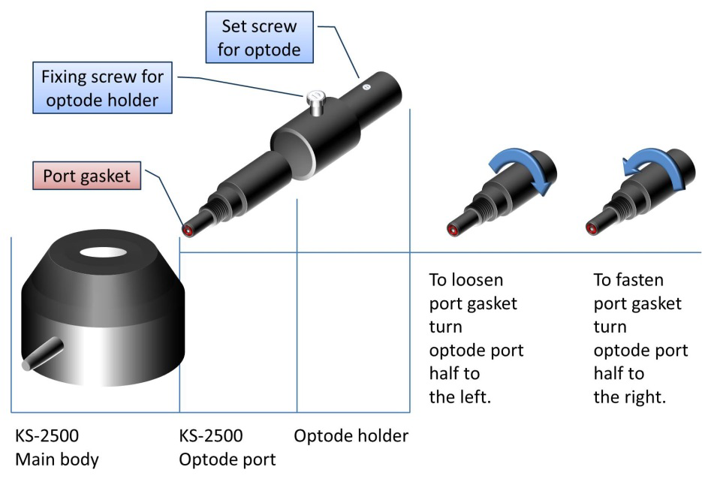
        + Turn optode port half to the left to loosen port gasket.
        + Carefully insert needle in optode adapter and syringe port. The adapter aligns the needle so that its tip meets the opening of the 1 mm ø hole through the cuvette wall.
        + Visually examine the position of the needle tip in the interior.
        + The stir bar inside the cuvette will turn clockwise. Turning the needle until the bevel at needle top is exposed to the flow caused by stirring will increase signal response.
        + Retract needle until the tip just disappears. Gently tighten up the optode setscrew using a blade-type screwdriver in the Firesting case.
        + Turn optode port half to the right to secure port gasket.
      * Turn on the stir plate and visually examine stir bar rotation. Start experiments with control knob indicator in top position. Optimize rotational speed by considering particle settling and possible mechanical stress. Note that short intervals of high rotational speed can release bubbles from the cuvette wall which then can escape through the O-ring gap.
* Pipette 500uL of sample into the cuvette.
* Cover sample with the adapter. Make sure there are no bubbles.
  + - * 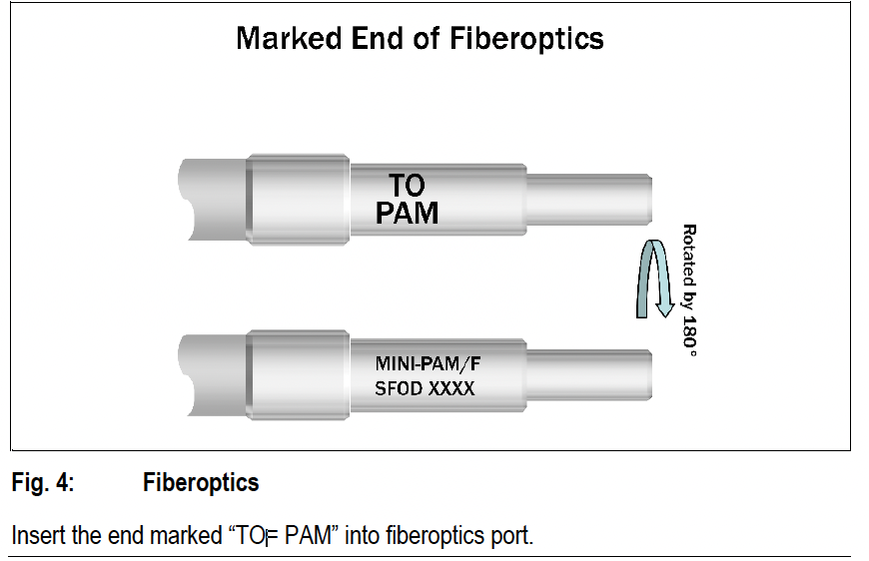
      * Add the grey fiber optic cable on top of the adapter. Plug the other end of the fiber optic cable into the PAM. Do not bend the fiber optic cable!!! Follow the natural curves in the cable. Use the metal brace to support the cable, as pictured. The side of the cable that says “to PAM” should be plugged into the PAM. Do not touch ends of fiber optic cable with your fingers and always ensure these ends are clean and free from debris. If debris is present, use a Kimwipe or microscope lens cloth to gently wipe it clean. Always store fiber optic cable with dust caps attached.
      * Once fiberoptic cable is slotted into the cuvette, the clock starts on dark acclimation.
  + Calibrate the instrument the day before. Plan to calibrate ~ once a week.
  + Taking measurements
    - Dark-acclimate the sample for at least 10 minutes before taking measurements.
    - Turn on the Mini-PAM (push black power button on the PAM).
    - Open Win-Control-3 software on computer.
    - Check “Rec. Online” box in upper right corner of display.
    - Move oxygen sensor into “measurement” position (position 1).
    - Under “Settings” tab, confirm that PAM settings are correct.
    - On first tab, check the “LC” box.
    - Let the PAM run through its measuring cycle. 10-minute light intervals, of 8 light intervals, plus 10 minutes dark acclimation, plus sample prep on both ends, means ~2 hours/sample.
  + ^can run a max of 2 samples a day, including blanks
  + Randomly select order of treatments. Run for a week, leads to n=2. Run for 3 weeks in a row; ideally weeks 3, 4, and 5, leads to n=6. Could run earlier but I think the gametophytes might be too small at that point.
  + Calibrate sensor on Sunday; day before.
  + Disassembly
    - If oxygen sensor is being used the next day, just rinse sensor in DI water, but sensor can stay plugged into cuvette. If not being used within 24 hours, disassemble the sensor.
    - After use, rinse oxygen sensor thoroughly with demineralized water to prevent salt crystallization inside the needle.
    - Retract the sensor tip into the needle after drying. Put on the protective cap onto the needle to avoid injuries.
    - Store sensor in a dry, dark and secure place.
* Analyze images in ImageJ (can be handled by an undergrad using my image guide).